Name:
Easier
Harder
Easier
1 | Name the type of triangle below:  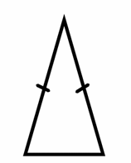 | 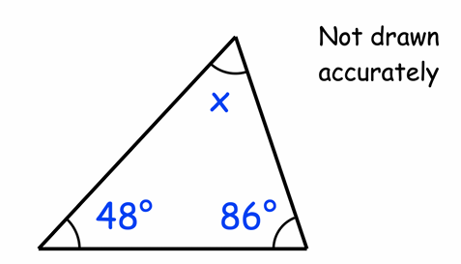  Work out the size of angle x?  x= | 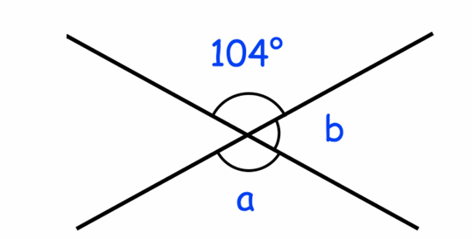  Work out the size of angle ‘a’ and ‘b’.  a=  b= | 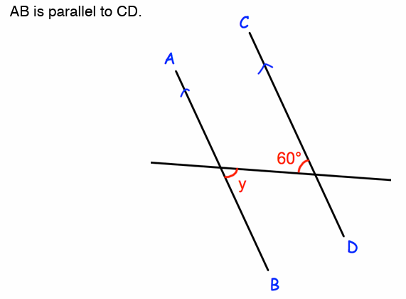  What is the size of angle y?  y=
2 | 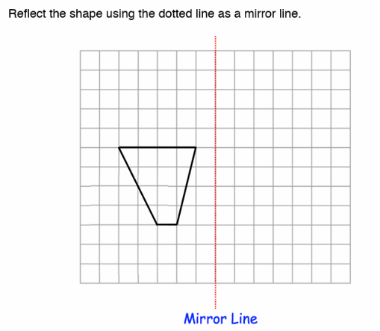  Reflect the shape in the mirror line. | 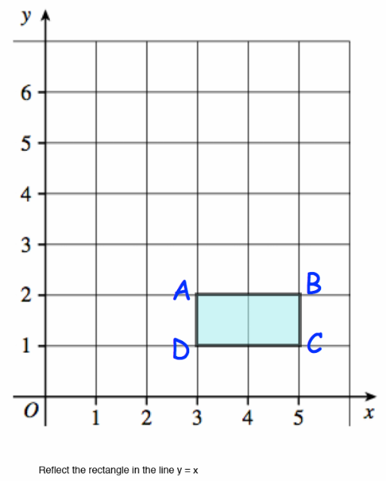  Reflect the shape in the line y=x | 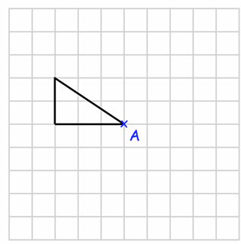  Rotate the triangle 90º clockwise, about A. | 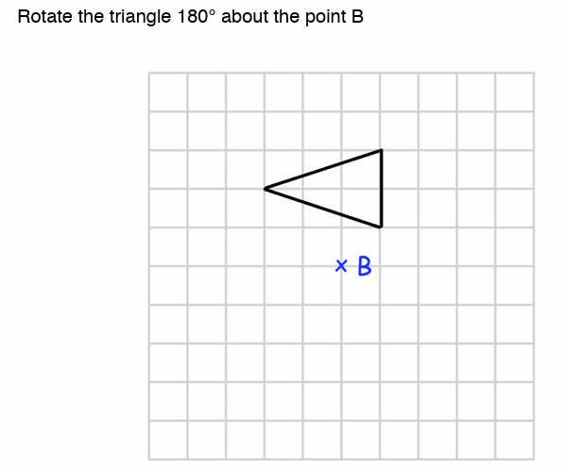  Rotate the triangle 180º about the point B.
3 | 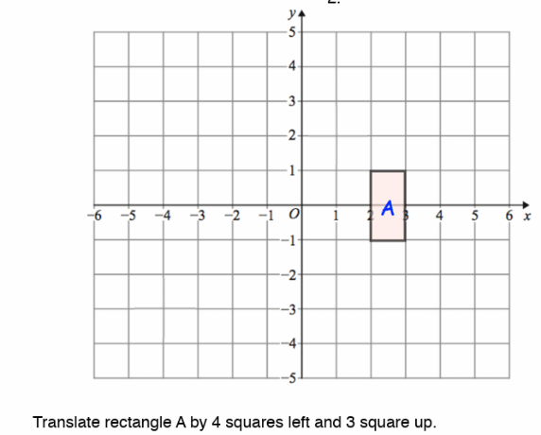  Translate the rectangle 4 squares left and 3 squares up. | 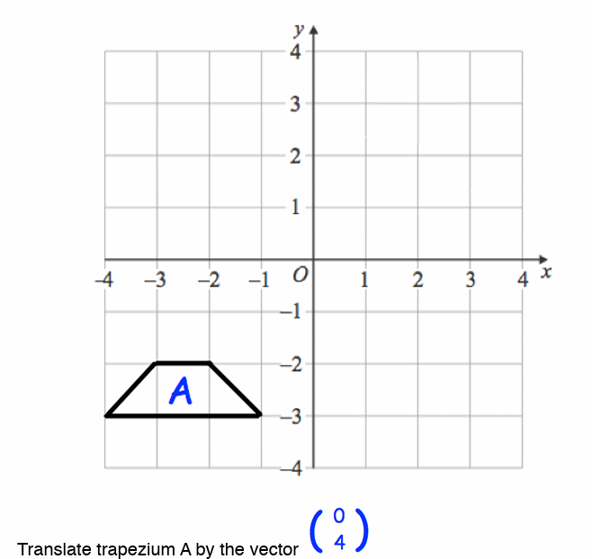  Translate the trapezium by the vector 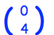 | 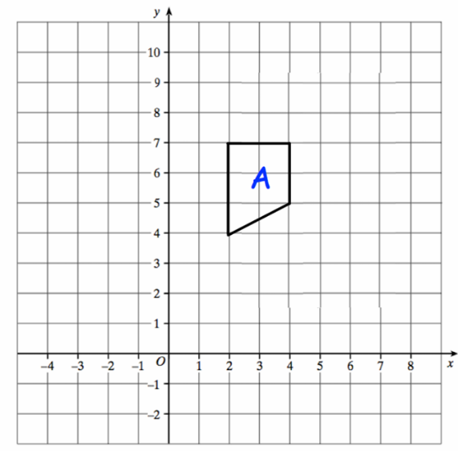  Translate the trapezium by the vector  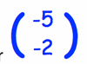 | 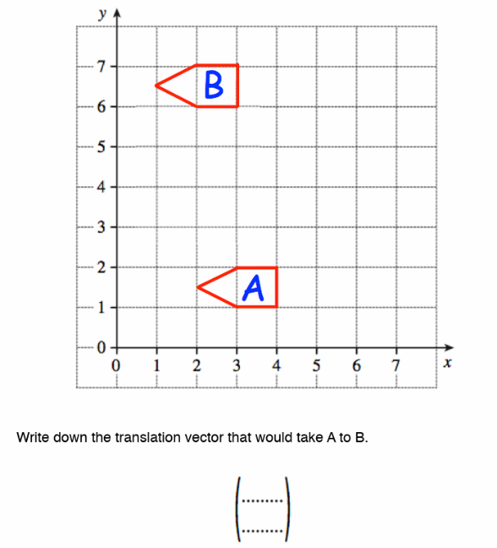 Write down the vector that would translate A to B  ( )

 | RECALL
 | 329 + 479 | 778 - 387 | Write down the ratio of squares to circles in its simplest form.  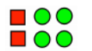 | Simplify the ratio 6:10
 | 18 x 25 | 2826 $÷$ 6 | 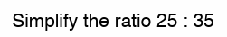 | 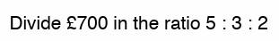
 | Write 6.2 x 10⁵ in ordinary form. | Simplify:  12⁶ $÷$ 12²= | Simplify:  4c + 3d -c |  | Expand the brackets:  3(y + 7) =
 | Calculate -16 + 5 = | 2 + 3 x 4 = | Solve:  3 + 2x = 15 |  | Factorise:  4a² – 2a

